FOR IMMEDIATE RELEASE
Press contacts:
Jay Kelly, LCWA Jim Jarvis, Paramount Theatre
jkelly@lcwa.com or 312.565.4623 jimj@paramountarts.com or 630.723.2474
LAAAA-DY! KING OF COMEDY JERRY LEWIS PLAYING
AURORA’S PARAMOUNT THEATRE, SUNDAY, OCT. 26 AT 3 P.M.

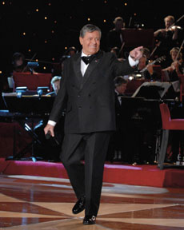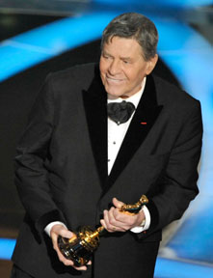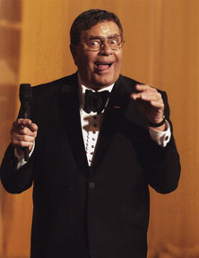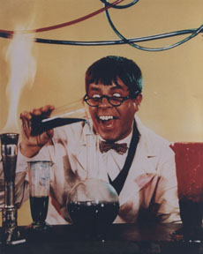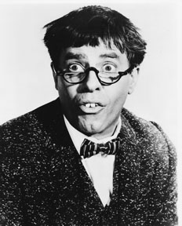
Click here to download images of Jerry Lewis from Paramount’s online press center.

AURORA, IL, September 17, 2014 – Jerry Lewis is one of the most recognized personalities on the planet! He’s an Academy Award winner, Hollywood/Las Vegas icon, Nobel Peace Prize nominee and international treasure.

Now you can spend the afternoon with Jerry Lewis at downtown Aurora’s beautiful Paramount Theatre Sunday, October 26 at 3 p.m. as he shares stories and rarely seen film clips of some of his greatest moments on screen with some of the greatest entertainers in history.

It’s ONE AFTERNOON ONLY with one of the most unforgettable personalities in entertainment. And let’s not forget the jokes you’ll want to remember to retell your friends and the hilarious Q&A with the audience. You never know, you may get that chance of a lifetime and talk to the King of Comedy.

Tickets are only $45 and $65. The Paramount Theatre is located at 23 E. Galena Blvd. in downtown Aurora. For tickets and information, visit ParamountAurora.com, call (630) 896-6666, or purchase in person at the Paramount box office, 10 a.m. to 6 p.m., Monday through Saturday. Rated PG-13.

Jerry Lewis – “The King of Comedy”

Jerry Lewis (born March 16, 1926) is an American comedian, actor, singer, film producer, screenwriter and film director. He is known for his slapstick humor in film, television, stage and radio. He was originally paired up with Dean Martin, forming the famed comedy team of Martin and Lewis. In addition to the duo's popular nightclub work, they starred in a successful series of comedy films for Paramount Pictures. Lewis has won several awards for lifetime achievements from The American Comedy Awards, Los Angeles Film Critics Association, and Venice Film Festival, and he has two stars on the Hollywood Walk of Fame. In 2005, he received the Governors Award of the Academy of Television Arts & Sciences Board of Governors, which is the highest Emmy Award presented. On February 22, 2009, the Academy of Motion Picture Arts and Sciences awarded Lewis the Jean Hersholt Humanitarian Award.
-more-

Paramount presents Jerry Lewis 10.26 – pg 2 of 3

Jerry’s Paramount Connection
In the 1920s, “talkies” began to appear, and Paramount Pictures began to build theaters around the country to screen their latest films. The Paramount Theatre in Aurora opened in September 1931 with appearances from Paramount film stars including The Marx Brothers, Jack Benny, and Burns and Allen.

Paramount’s studio system was still in full swing nearly 20 years later, when Jerry Lewis began his film career with Dean Martin in 1949 as ensemble players in My Friend Irma and My Friend Irma Goes West. Starting with At War with the Army (1950), Martin and Lewis were the stars of 15 Paramount Pictures vehicles ending with Hollywood or Bust (1956). Lewis remained at Paramount Pictures after going solo and became a major comedy star with his first film as a solo comic, The Delicate Delinquent (1957), followed by such classics as Rock-A-Bye Baby (1958), The Geisha Boy (1958), Cinderfella (1960), The Ladies Man (1961), The Nutty Professor (1963), It's Only Money (1962), Who's Minding the Store? (1963) and The Family Jewels (1965).

Jerry Lewis at the Paramount is sponsored by Schmitt McDonald’s.

Also on stage in 2014-15 at the Paramount
In addition to Jerry Lewis, Paramount’s 2014-15 season boasts Broadway series opener CATS (Sept. 10-Oct. 12), Jim Brickman: The Platinum Tour "Celebrating 20 Years" (Oct. 18), Home Free, winners of NBC-TV’s The Sing-Off (Oct. 19), SPANK! The Fifty Shades Parody (Oct. 24), Recycled Percussion (Nov. 1), Brooks & Wine featuring country star Kix Brooks paired with a private wine tasting (Nov. 8), Under the Streetlamp, Chicago’s favorite former Jersey Boys (Nov. 9), Ballet Folklorico Quetzalcoatl (Nov. 14), the Chicago Comedy Tour with WGN Morning News’ Ana Belaval, Pat Tomasulo and Mike Toomey (Nov. 22, in the Copley Theatre), Paramount’s holiday season Broadway production Mary Poppins (Nov. 26, 2014-Jan. 4, 2015), The Second City Dysfunctional Holiday Revue (Dec. 5-21, in the Copley Theatre), Broadway series play three The Who’s Tommy (Jan. 14-Feb. 15), Vicki Lawrence & Mama: A Two Woman Show (Feb. 22), Tony, Emmy and Golden Globe winner John Lithgow in his one-man show Stories by Heart (Mar. 7), Defending the Caveman (Mar. 13-29, in the Copley Theatre), Broadway series finale Les Misérables (Mar. 18-Apr. 26), An Evening with David Sedaris, one of the top humorists of our time (Apr. 28), the internationally acclaimed, shape-shifting dance troupe Pilobolus (Apr. 30), and gal pal favorite Menopause the Musical (May 6-Jun. 28, in the Copley Theatre). Also back in 2014-15, Paramount’s popular $1 Classic Movie Mondays series, presenting everyone’s favorite flicks in one of Chicago’s top former movie palaces for just $1, and a line-up of children’s shows designed to entertain while they educate.

In addition to the lowest major theater subscription prices anywhere in Illinois, subscriber benefits at the Paramount have never been better. Purchase four or more shows and you automatically reap many benefits as a season subscriber, including the best seats in the house, easy ticket exchange privileges, and first notice of added shows and special subscriber events. Subscriber discounts range from 5% to 15% off single ticket prices, depending on how many shows you buy. To become a subscriber or to purchase single tickets to individual shows, please call the box office at (630) 896-6666, stop by in person at 23 E. Galena Blvd. in Aurora, or go online at ParamountAurora.com.

-more-

Paramount presents Jerry Lewis 10.26 – pg 3 of 3
About The Paramount Theatre

The Paramount Theatre is the center for performing arts, entertainment and arts education in Aurora, the second largest city in Illinois. Named "One of Chicago's Top 10 Attended Theatres" by the League of Chicago Theatres, the 1,888-seat Paramount Theatre, located in the heart of downtown Aurora at 23 E. Galena Blvd., is nationally renowned for the quality and caliber of its presentations, superb acoustics and historic beauty.

The Paramount Theatre opened on September 3, 1931. Designed by nationally renowned theater architects C.W. and George L. Rapp, the theater captures a unique Venetian setting portrayed in the art deco influence of the 1930s. The first air-conditioned building outside of Chicago, the Paramount offered the public a variety of entertainment, including "talking pictures," vaudeville, concerts and circus performances for more than 40
years. In 1976, Aurora Civic Center Authority purchased the Paramount and closed the theater for
Restoration. The $1.5 million project restored the Paramount to its original grandeur. On April 29, 1978, the Paramount Arts Center opened, offering a variety of theatrical, musical, comedy, dance and family programming. In 2006, a 12,000-square-foot, two-story Grand Gallery lobby was added, with a new, state-of-the-art box office, café and art gallery.

Today, the Paramount produces its own Broadway Musical series, presents an eclectic array of comedy, music, dance and family shows, and on most Mondays, screens a classic movie. For tickets and information, go to ParamountAurora.com or call (630) 896-6666.

The Paramount Theatre is one of three live performance venues programmed and managed by the Aurora Civic Center Authority (ACCA). ACCA also oversees the Paramount’s “sister” stage, the intimate, 216-seat Copley Theatre located directly across the street from the Paramount at 8 E. Galena Blvd., as well as RiverEdge Park, downtown Aurora’s new summer outdoor concert venue.
The Paramount Theatre continues to expand its artistic and institutional boundaries under the guidance of Tim Rater, President and CEO, Aurora Civic Center Authority; Jim Corti, Artistic Director, Paramount Theatre; a dedicated Board of Trustees and a devoted staff of live theater and music professionals.
Paramount’s 2014-15 Broadway Series is sponsored by the Dunham Fund, BMO Harris Bank and PACE (Paramount Arts Centre Endowment). Broadway Series Lighting Sponsor is ComEd. Broadway Series Costume Sponsor is Gerald Auto Group. For more information, visit ParamountAurora.com.
# # #

