FOR IMMEDIATE RELEASE
Press contacts:
Jay Kelly, LCWA Jim Jarvis, Paramount Theatre
jkelly@lcwa.com or 312.565.4623 jimj@paramountarts.com or 630.723.2474
INCREDIBLE A CAPPELLA COUNTRY ON TAP WHEN HOME FREE,
WINNERS OF NBC’S THE SING-OFF, BRINGS ITS CRAZY LIFE TOUR
TO AURORA’S PARAMOUNT THEATRE SUNDAY, OCT. 19

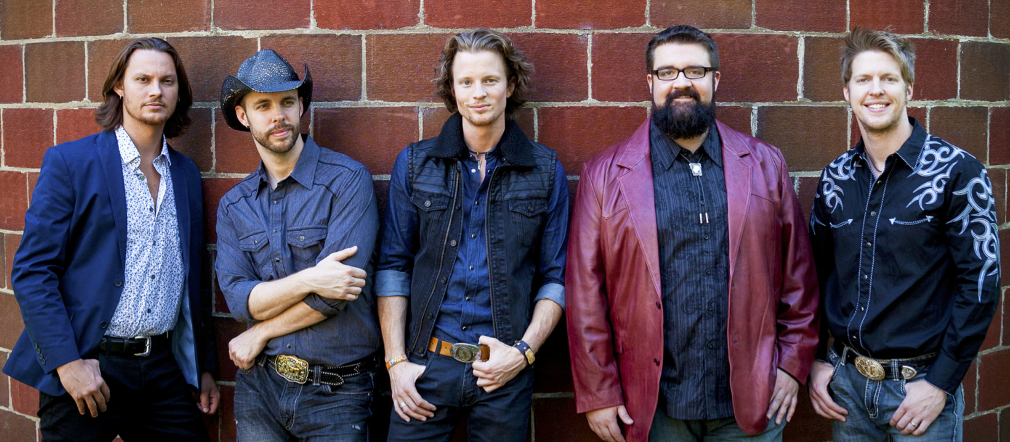
Click here to download images of Home Free from Paramount’s online press center.

AURORA, IL, August 18, 2014 – You’ll recognize Home Free from winning NBC-TV’s 2013 The Sing-Off. But it’s their unique ability to sing Nashville standards as well as pop hits with a country twist, and all in a cappella style that has really won over audiences. Combine that with their fun, warm, high-energy live performances, and you’ve got an evening that can only be described as “must-see.”
So mark your calendar for Sunday, October 19, when Home Free brings its national Crazy Life Tour to the Chicago area, one-night-only at the Paramount Theatre, 23 E. Galena Blvd. in downtown Aurora. The concert begins at 5 p.m. Tickets are $35 and $40. For tickets and information, visit ParamountAurora.com, call
(630) 896-6666, or purchase in person at the Paramount Theatre box office, 10 a.m. to 6 p.m., Monday through Saturday.

More about Home Free
When country a cappella band Home Free was crowned Season 4 Champions of NBC's The Sing-Off last December, their victory was by no means the beginnings of a career for the five country stars from Minnesota. Rather it was a satisfying culmination of nearly a decade of hard work and commitment to a vocal craft growing in popularity.

Founded by brothers Chris and Adam Rupp during their college years in the early 2000s, Home Free had been perfecting their live show for years prior to The Sing-Off – performing together for crowds in countless state and county fairs, on college campuses, in Fortune 500 companies, and in theaters all across the country. It was their experience on the road that carried them to a Sing-Off victory, swelling their fan base and bringing their homegrown country style into a national spotlight.
-more-

Paramount presents Home Free 10.19 – pg 2 of 3

Home Free continues to entertain audiences with their high-energy show peppered with quick-witted humor that meshes Nashville standards with pop hits dipped in country flavor. Last spring they continued their journey with a 32-city, 36-show Sing-Off Tour Live! on the heals of their Columbia Records debut release, Crazy Life, followed by another busy summer festival circuit before launching their current fall Crazy Life Tour. For more information, visit HomeFreeVocalBand.com.

Also on stage in 2014-15 at the Paramount
In addition to Home Free, Paramount’s 2014-15 season boasts The Happy Together Tour (Aug. 22), 11-year-old rap phenom Matty B (Aug. 23), Donny & Marie (Aug. 27-31), CATS (Sept. 10-Oct. 12), Penn & Teller (Oct. 17), Jim Brickman: The Platinum Tour "Celebrating 20 Years" (Oct. 18), Spank! The Fifty Shades Parody (Oct. 24), Jerry Lewis (Oct. 26), Recycled Percussion (Nov. 1), Brooks & Wine featuring country star Kix Brooks paired with a private wine tasting (Nov. 8), Under the Streetlamp, Chicago’s favorite former Jersey Boys (Nov. 9), Ballet Folklorico Quetzalcoatl (Nov. 14), the Chicago Comedy Tour with WGN Morning News’ Ana Belaval, Pat Tomasulo and Mike Toomey (Nov. 22, in the Copley Theatre), Mary Poppins (Nov. 26, 2014-Jan. 4, 2015), The Second City Dysfunctional Holiday Revue (Dec. 5-21, in the Copley Theatre), The Who’s Tommy (Jan. 14-Feb. 15), Vicki Lawrence & Mama: A Two Woman Show (Feb. 22), Tony, Emmy and Golden Globe winner John Lithgow in his one-man show Stories by Heart (Mar. 7), Defending the Caveman (Mar. 13-29, in the Copley Theatre), Les Miserables (Mar. 18-Apr. 26), An Evening with David Sedaris, one of the top humorists of our time (Apr. 28), the internationally acclaimed, shape-shifting dance troupe Pilobolus (Apr. 30), and gal pal favorite Menopause the Musical (May 6-Jun. 28, in the Copley Theatre). Also back in 2014-15, Paramount’s popular $1 Classic Movie Mondays series, presenting everyone’s favorite flicks in one of Chicago’s top former movie palaces for just $1, and a line-up of children’s shows designed to entertain while they educate.

In addition to the lowest major theater subscription prices anywhere in Illinois, subscriber benefits at the Paramount have never been better. Purchase four or more shows and you automatically reap many benefits as a season subscriber, including the best seats in the house, easy ticket exchange privileges, and first notice of added shows and special subscriber events. Subscriber discounts range from 5% to 15% off single ticket prices, depending on how many shows you buy. To become a subscriber or to purchase single tickets to individual shows, please call the box office at (630) 896-6666, stop by in person at 23 E. Galena Blvd. in Aurora, or go online at ParamountAurora.com.
About The Paramount Theatre

The Paramount Theatre is the center for performing arts, entertainment and arts education in Aurora, the second largest city in Illinois. Named "One of Chicago's Top 10 Attended Theatres" by the League of Chicago Theatres, the 1,888-seat Paramount Theatre, located in the heart of downtown Aurora at 23 E. Galena Blvd., is nationally renowned for the quality and caliber of its presentations, superb acoustics and historic beauty.

The Paramount Theatre opened on September 3, 1931. Designed by nationally renowned theater architects C.W. and George L. Rapp, the theater captures a unique Venetian setting portrayed in the art deco influence of the 1930s. The first air-conditioned building outside of Chicago, the Paramount offered the public a variety of entertainment, including "talking pictures," vaudeville, concerts and circus performances for more than 40
years. In 1976, Aurora Civic Center Authority purchased the Paramount and closed the theater for
restoration. The $1.5 million project restored the Paramount to its original grandeur. On April 29, 1978, the Paramount Arts Center opened, offering a variety of theatrical, musical, comedy, dance and family programming. In 2006, a 12,000-square-foot, two-story Grand Gallery lobby was added, with a new, state-of-the-art box office, café and art gallery.

Today, the Paramount produces its own Broadway Musical series, presents an eclectic array of comedy, music, dance and family shows, and on most Mondays, screens a classic movie. For tickets and information, go to ParamountAurora.com or call (630) 896-6666.
-more-

Paramount presents Home Free 10.19 – pg 3 of 3

The Paramount Theatre is one of three live performance venues programmed and managed by the Aurora Civic Center Authority (ACCA). ACCA also oversees the Paramount’s “sister” stage, the intimate, 216-seat Copley Theatre located directly across the street from the Paramount at 8 E. Galena Blvd., as well as RiverEdge Park, downtown Aurora’s new summer outdoor concert venue.

The Paramount Theatre continues to expand its artistic and institutional boundaries under the guidance of Tim Rater, President and CEO, Aurora Civic Center Authority; Jim Corti, Artistic Director, Paramount Theatre; a dedicated Board of Trustees and a devoted staff of live theater and music professionals.
Paramount’s 2014-15 Broadway Series is sponsored by the Dunham Fund, BMO Harris Bank and PACE (Paramount Arts Centre Endowment). Broadway Series Lighting Sponsor is ComEd. For more information, visit ParamountAurora.com.
# # #

