FOR IMMEDIATE RELEASE
Press contacts:
Jay Kelly, LCWA Jim Jarvis, Paramount Theatre
jkelly@lcwa.com or 312.565.4623 jimj@paramountarts.com or 630.723.2474
FIVE TOP FAVE HOLIDAY FLICKS ADD UP TO A FAMILY-FRIENDLY,
CLASSIC MOVIE MONDAYS LINE-UP AT AURORA’S PARAMOUNT THEATRE
Enjoy A christmas story, it’s a wonderful life, national lampoon’S christmas vacation, home alone and polar express for only $1 on paramount’s silver screen
ALSO ANNOUNCED: pARAMOUNT’S CLASSIC MOVIE MONDAYS LINE-UP THROUGH JUNE 2014
AURORA, IL, November 20, 2013 – What would Christmas be without laughing at Ralphie’s quest for a Red Ryder BB gun, weeping as George Bailey realizes how many lives he’s touched, feeling the pain at the Griswolds’ attempts at a perfect Christmas, rooting for that little guy left home alone over the holidays, or following a magic train as it takes a doubting boy to Santa’s home at the North Pole?
A sad holiday season indeed. But thanks to the Classic Movie Mondays line-up this December at the Paramount Theatre, 23 E. Galena Boulevard in downtown Aurora, everyone’s favorite classic holiday flicks are being screened on the Paramount’s gigantic silver screen for just $1.
So gather the family and take them on affordable outings to their favorite holiday flicks screened in the Paramount’s beautiful art deco theater, complete with crystal clear digital projection, perfect acoustics, no trailers, buttered popcorn and a full-service bar. Movies start promptly at 7 p.m. For more information, call the Paramount box office at (630) 896-6666 or visit paramountaurora.com.
Following is the Paramount’s December Classic Movie Mondays line-up, followed by the newly announced schedule through June 2014:
A Christmas Story – December 2
In the small town of Hohman, Indiana, a young boy named Ralphie Parker pleads with his family for a Red Ryder BB gun, only to be warned: “You’ll shoot your eye out.” A series of comic misadventures besets the Parker household, leading to a memorable Christmas for all. Starring Peter Billingsley, Darren McGavin, and Melinda Dillon. Directed by Bob Clark. Rated PG. 94 minutes. 1983.
-more-
Classic Movie Mondays – pg 2 of 4
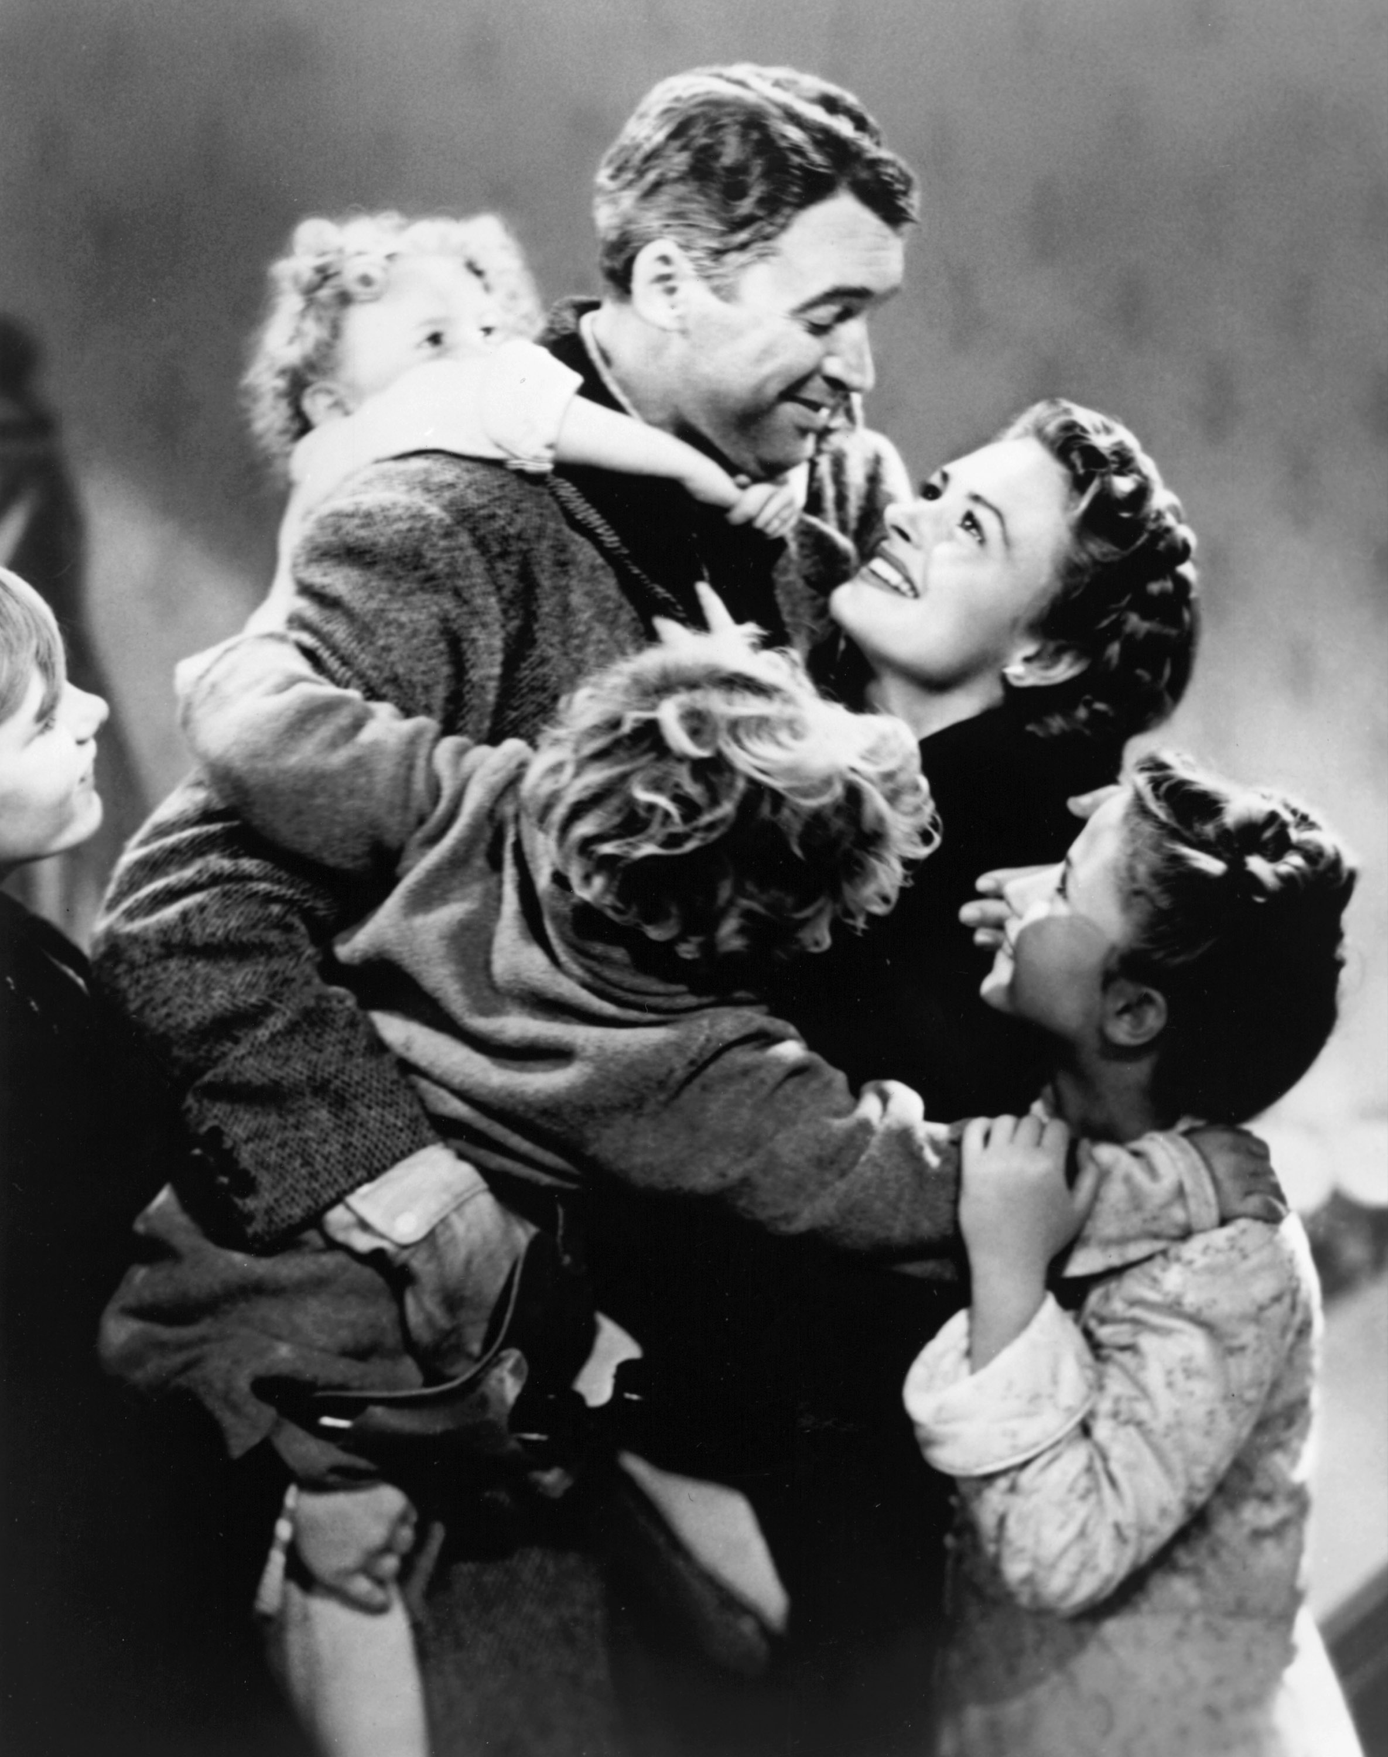
It’s A Wonderful Life – December 9
Good-hearted, idealistic George Bailey is stricken with ruin and despair, and contemplates that his loved ones would be better off if he’d never been born. A compassionate angel grants him a look at such a world, and Bailey begins to understand how many lives he’s touched and how many of those lives touched him back. Starring James Stewart, Donna Reed, and Lionel Barrymore. Directed by Frank Capra. Rated PG. 130 minutes. 1946.
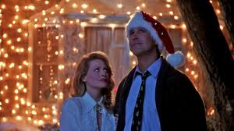
National Lampoon’s Christmas Vacation – December 16
In the third installment of National Lampoon‘s uproarious series of Vacation films, the Griswold family learns that even when they stay home for the holidays they can’t seem to avoid trouble. Clark’s attempt to have a perfect Christmas is thwarted by sledding mishaps, home decorating misfires, and the quirks of his extended family. Starring Chevy Chase, Beverly D’Angelo, and Randy Quaid. Directed by Jeremiah S. Chechik. Rated PG-13. 97 minutes. 1989.
Home Alone – December 23
Young Kevin McCallister has been left at home alone when his family accidentally takes off for vacation without him. While Kevin’s mother tries desperately to get home, Kevin gets into mischief and protects his house against a pair of bumbling burglars. Starring McCauley Culkin, Joe Pesci, Catherine O’Hara and Daniel Stern. Directed by Chris Columbus. Rated PG. 103 minutes. 1990.
-more-

Classic Movie Mondays – pg 3 of 4
Plus, a special added morning movie on Christmas Eve!
The Polar Express – Tuesday, December 24, 11 a.m.
Kick off your Christmas Eve preparations with a morning trip to the Paramount for The Polar Express. Based on the beloved book by Chris Van Allsburg and featuring a breakthrough style of animation, The Polar Express is a delight in both story and visuals for the whole family. Featuring the voices of Tom Hanks, Chris Coppola, and Michael Jeter. Directed by Robert Zemeckis. Rated PG. 100 min. 2004.
After the holidays, come back to the Paramount on the following Monday nights at 7 p.m. for Classic Movie Mondays screenings of:

E.T., The Extraterrestrial (1982) – December 30
An Officer and A Gentleman (1982)–January 20
The French Connection (1971) – January 27
Rear Window (1954) – February 3
Groundhog Day (1993) – February 10
*Cooley High (1975) – February 17
*Lilies of the Field (1963) – February 24
Sleepless in Seattle (1993) – March 17
Pulp Fiction (1994) – March 24
The Wizard of Oz (1939) – March 31
The Good, the Bad and the Ugly (1966)– April 7
All About Eve (1950) – April 14
Jerry Maguire (1996) – April 21
First Blood (1982) – April 28
The Omen (1976) – May 5
The Odd Couple (1968) – May 12
Some Kind of Wonderful (1987) – May 19
King Kong (1933) – May 26
Jurassic Park (1993) – June 2
The Muppet Movie (1979) – June 9
Raiders of the Lost Ark (1981) – June 16
The Goonies (1985) – June 23
Superman II (1981)– June 30

Paramount Theatre’s Classic Movie Mondays series is sponsored by Waubonsee Community College.
*Classic Movie Monday screenings of Cooley High (February 17) and Lilies of the Field (February 24) are sponsored by the Aurora African-American Heritage Advisory Board in recognition of Black History Month.
-more-

Classic Movie Mondays – pg 4 of 4
About The Paramount Theatre
The Paramount Theatre is the center for performing arts, entertainment and arts education in Aurora, the second largest city in Illinois. Named “One of Chicago’s Top 10 Attended Theaters” by the League of Chicago Theaters, the 1,888-seat Paramount Theatre, located in the heart of downtown Aurora at 23 E. Galena Boulevard, is nationally renowned for the quality and caliber of its presentations, superb acoustics and historic, Art Deco beauty.
The Paramount Theatre opened on September 3, 1931. Designed by nationally renowned theater architects C.W. and George L. Rapp, the theater captures a unique Venetian setting portrayed in the art deco influence of the 1930s. The first air-conditioned building outside of Chicago, the Paramount offered the public a variety of entertainment, including "talking pictures," vaudeville, concerts and circus performances for more than 40 years.
Today, the Paramount produces its own, self-produced Broadway Musical series, presents an eclectic array of comedy, music, dance and family shows, and on most Mondays, screens a classic movie.
The Paramount Theatre is one of three live performance venues programmed and managed by the Aurora Civic Center Authority (ACCA). ACCA also oversees the Paramount’s “sister” stage, the intimate, 216-seat Copley Theatre located directly across the street from the Paramount at 8 E. Galena Blvd., as well as RiverEdge Park, downtown Aurora’s new summer outdoor concert venue.
The Paramount Theatre continues to expand its artistic and institutional boundaries under the guidance Tim Rater, President and CEO, Aurora Civic Center Authority; Jim Corti, Artistic Director, Paramount Theatre; a dedicated Board of Trustees and a devoted staff of live theater and music professionals.

The 2013-14 Paramount Theatre season is sponsored by The Daily Herald. The 2013-14 Paramount Broadway Season is sponsored by BMO Harris. This season is partially supported by a grant from the Illinois Arts Council, a state agency.

For more information, visit the Paramount Theatre online at ParamountAurora.com.
# # #

