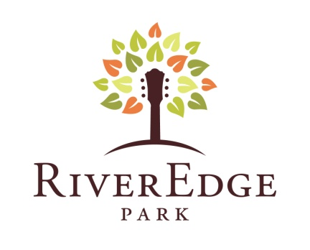
Summer 2013 Concert and Events Calendar
Contact: Jay Kelly, L.C. Williams & Associates
jkelly@lcwa.com, 312.565.4623, 312.315.3935 (cell)
360 Broadway St. Aurora, IL 60505
riveredgeaurora.com 630.896.6666
FOR IMMEDIATE RELEASE
INAUGURAL SEASON AT AURORA’S RIVEREDGE PARK MUSIC GARDEN,
CHICAGO’S NEWEST OUTDOOR ENTERTAINMENT VENUE, INCLUDES BLUES ON THE FOX, LORETTA LYNN AND RANDY TRAVIS, PETER FRAMPTON’S GUITAR CIRCUS, TRACE ADKINS, SAIL ROCK, SING-A-LONG-A GREASE, 4TH OF JULY FIREWORKS, SPORTS EVENTS AND MORE
Go to http://paramountaurora.com/press-kits/ to download hi-res images of artists and events scheduled this summer at Aurora’s new RiverEdge Park Music Garden.
AURORA, IL, April 15, 2013 – Downtown Aurora’s new RiverEdge Park Music Garden, opening June 14 and 15 with the city’s 17th Annual Blues on the Fox festival, is sure to be an exciting new addition to the short list of outdoor entertainment venues in and around Chicago.
The new RiverEdge Park is conveniently located at 360 North Broadway, just steps away from downtown Aurora, directly across from the Metra station, on the east bank of the beautiful Fox River. The venue is anchored by the contemporary new John C. Dunham performance pavilion, which boasts total capacity of as much as 10,500.
Today, Aurora Mayor Thomas Weisner and Tim Rater, President and CEO of the Aurora Civic Center Authority, announced the initial line-up of concerts, festivals and special events slated for the inaugural season this summer at RiverEdge Park Music Garden. The RiverEdge website, riveredgeaurora.com, launches today, Monday, April 15 at 10 a.m. Tickets to one of the most hotly anticipated acts, country music superstars Loretta Lynn and Randy Travis, go on sale Saturday, April 20 at 10 a.m. Tickets to all performances go on sale Monday, April 22 at 10 a.m. Tickets can also be purchased via phone at 630.896.6666. The preliminary line-up follows. Stay tuned for a few more major concert announcements within the next few weeks:
Press Preview
Thursday, May 9, Noon
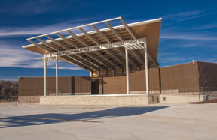 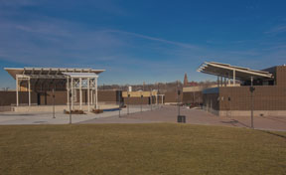 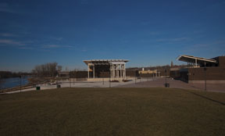 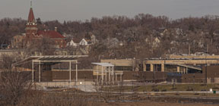
Chicago-area media will be invited to an exclusive sneak-peek Press Preview of the new RiverEdge Music Garden. Includes lunch on the RiverEdge Rooftop Deck, tours, and a meet-and-greet with Aurora Mayor Thomas Weisner and RiverEdge Park architect David Steele, Muller & Muller Ltd. Architects.
-more-

RiverEdge Music Garden Summer Schedule.4.15.13.pg 2 of 7
All Access Week
June 3-9
Free
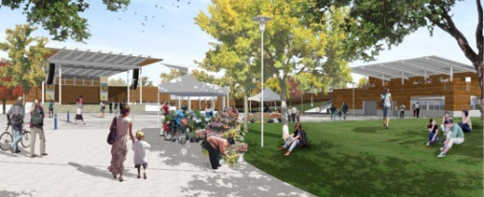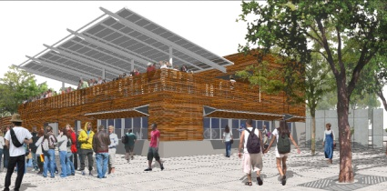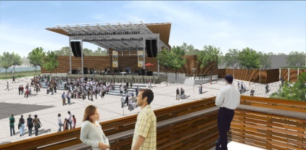
From June 3-9, RiverEdge will hold its All Access Week events which include the Meet-N-Greet public tours June 3-6; The Mayor’s Front Row Preview Party and Ribbon Cutting on June 7; and the Backstage Pass public tours on June 8 and 9. More information to come.
Blues on the Fox
Friday, June 14 at 6 p.m., Saturday, June 15 from 3 p.m. to 10:30 p.m.
Tickets: $10/day or $15/2-day pass general admission; $30/day or $50/2-day pass seated; $60 Skydeck/day
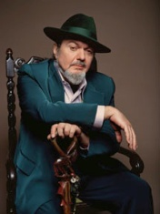 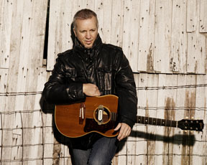 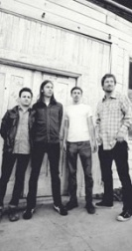 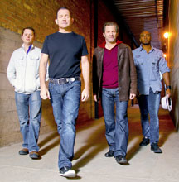 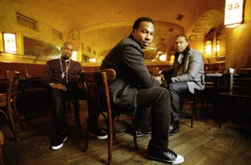
Featuring (from left) Dr. John, JJ Grey, The Stone Foxes, Tommy Castro and The Painkillers and Robert Randolph and The Family Band
Friday night features live sets by JJ Grey & Mofro, ready to deliver their front porch blend of Southern Rock and soul to Aurora’s doorstep, and nationally acclaimed New Orleans blues legend and Rock and Roll Hall of Fame member Dr. John. Saturday kicks off with the rockin, foot-stompin’ Bay area blues rockers The Stone Foxes, followed by stripped down, turbo charged Tommy Castro and The Painkillers, pedal steel guitar virtuoso and brand new Blue Note Record recording artist Robert Randolph and The Family Band and more artists TBA
Amped Up Adventure Race
Sunday, June 16 (Father’s Day)
To register and for more details visit ampedupadventurerace.com
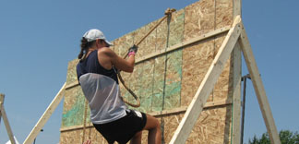
What’s an Amped Up Adventure Race? Exactly what it says: an amped up adventure for runners that want to have fun while pushing it to the limit. With a combination of sprinting, running, biking and paddling, the Amped Up Adventure Race also includes a patterned urban obstacle course. Individual runners welcome, or grab your friends and form a team. Better yet, plan an unforgettable Father’s Day and bring the whole family out to RiverEdge Park.
-more-

RiverEdge Music Garden Summer Schedule.4.15.13.pg 3 of 7
97Nine and American English
Friday, June 28, 6 p.m.
Tickets: $5, children 12 and under free/ $50 Skydeck
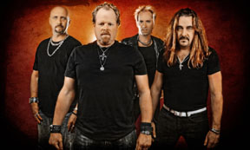 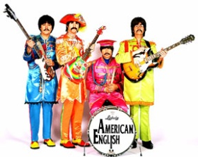
97 Nine American English
The premier classic rock cover band in the Midwest, 97Nine grew up listening to Chicago’s Loop 97.9FM rock radio, and thusly jams out to the most memorable arena rock anthems from the 80′s, 90′s and today. The closest you will ever get to reliving The Beatles, American English performs songs spanning their entire career from 1963-1970 with precise attention to every musical aspect, including costume changes, vintage instruments and special effects.
Loretta Lynn and Randy Travis
Saturday, June 29, 8 p.m.
Tickets: $45 general admission/$55 seated
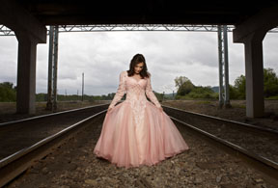 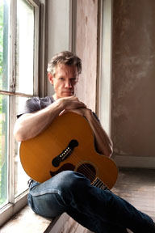
Loretta Lynn Randy Travis
With 50 years under her cowgirl belt, Loretta Lynn has undoubtedly earned the title First Lady of Country Music. With 16 number one hits, including Don't Come Home A' Drinkin' (With Lovin' on Your Mind), You Ain't Woman Enough, Fist City and Coal Miner's Daughter, this queen of country music set the way for female country artists. Who better to accompany Loretta than Randy Travis, the country music legend who has sold over 25 million records and earned 22 number one hits, 6 number one albums, 6 Grammy awards, 6 CMA awards, 9 ACM awards, 10 AMA awards, 7 Dove awards, and a star on the Hollywood Walk of Fame.
Bruce in the USA and Fox Valley Orchestra with post-concert Fireworks
Thursday, July 4, 6 p.m.
Free
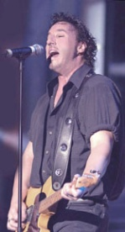
Bring the family to celebrate July 4th with the Fox Valley Orchestra, followed by Bruce in the USA, a high-energy, note-perfect and visually accurate recreation of a Bruce Springsteen & The E St. Band show, followed by fireworks.
-more-

RiverEdge Music Garden Summer Schedule.4.15.13.pg 4 of 7
Color Vibe 5K Race
Saturday, July 6, 8 a.m.
Limited space available. Register at http://www.thecolorvibe.com/aurora.php
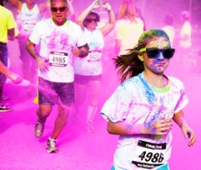
The Color Vibe 5K is not about crossing the finish line first but how colorful you get along the way. As you run through downtown Aurora, along the serene Fox River and end up in RiverEdge Park, you’ll be blasted with vibrant color powders that make tie-dyeing so yesterday. Families welcome. If you don’t want to race, come by and cheer on the color runners.
Trace Adkins, Aaron Lewis, Blackberry Smoke and Drake White
Saturday, July 13, 4 p.m.
Tickets: $35 general admission/$50 seated
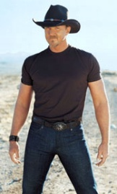 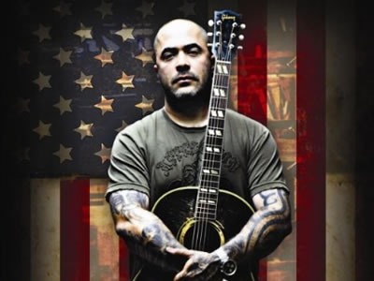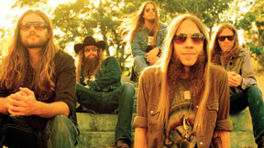 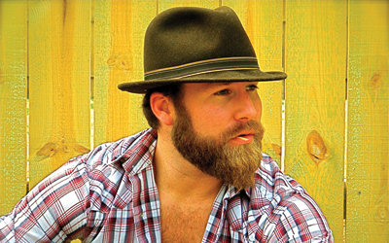
Trace Adkins Aaron Lewis Blackberry Smoke Drake White
With more than 20 singles on Billboard’s Country charts, honky tonk legend and NBC Celebrity Apprentice All-Star Trace Adkins is the southern gentleman all the girls crush on and the guy’s guy that all the men want to party with. Aaron Lewis, from the rock group Staind, is leaving his mark on the country music world with hits like Country Boy, Forever and Endless Summer. Blackberry Smoke is a true southern rock country band, think Lynyrd Skynyrd with a twang. Drake White is turning his Kid Rock sound into the next big thing in the country music world.
Two Brothers Roundhouse produced concert TBA
Saturday, July 20
Stay tuned for an announcement later this spring about three additional outdoor concerts programmed by RiverEdge Park Music Garden food vendor Two Brothers Brewery.
Sing-a-long-a Grease Movie in the Park
Friday, August 9, 8 p.m.
Tickets: $5
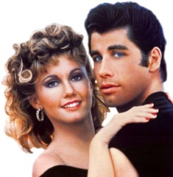
Whether you’re a T-bird or a Pink Lady, Goody-Two-Shoes or a beauty school dropout, everyone will LOVE belting out We Go Together, doing the Hand Jive and singing You’re The One That I Want. See the hit musical from 1978 on the big screen, where dancing is encouraged and singing is mandatory. Don’t be a fool, dressing up is cool! Prizes awarded for best costumes.
-more-

RiverEdge Music Garden Summer Schedule.4.15.13.pg 5 of 7
Sail Rock
Featuring Christopher Cross, Orleans, Gary Wright, Firefall, John Ford Coley, Robbie Dupree and Player
Saturday, August 10, 8 p.m.
Tickets: $30 general admission/$60 reserve seating
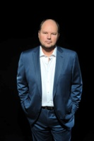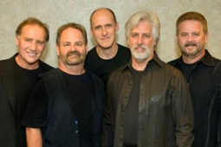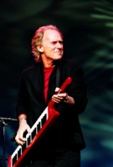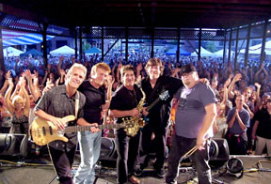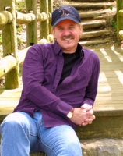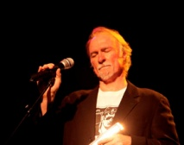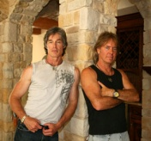
(from left) Christopher Cross, Orleans, Gary Wright, Firefall, John Ford Coley, Robbie Dupress and Player
Seven great artists share the stage for the first time in one unforgettable night, with a set list that plays like a soundtrack to the summers of the 70’s and early 80’s. Starring Grammy Winner Christopher Cross best known for his Top Ten hits Sailing, Ride Like the Wind and Arthur’s Theme (Best That You Can Do). Also featuring rockers Firefall with top 40 hits Just Remember I Love You, You Are the Woman and Strange Way. Dance with your sweetheart to Orleans and their Top 10 hits Dance with Me and Still The One. Gary Wright, whose Dream Weaver and Love Is Alive spent time at the #2 spot on Billboard’s Hot 100 in 1976, joins this feel-good lineup along with Grammy nominated John Ford Coley whose triple-platinum and gold records include I’d Really Love to See You Tonight and Love is the Answer. Rounding out the lineup are Robbie DuPree, remembered for his 1980 Top 10 hit Steal Away, and Player with their #1 Hit Baby Come Back.
Peter Frampton’s Guitar Circus
With Peter Frampton, Sonny Landreth and B.B. King
Friday, August 16, 6:30 p.m.
Tickets: $35 general admission/$55 seated
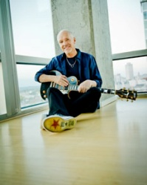 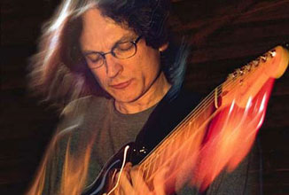 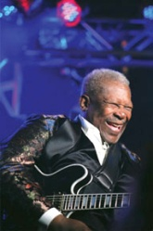
Peter Frampton Sonny Landreth B.B. King
Following the success of the 2011/2012 world tour celebrating the 35th Anniversary of his multi-platinum selling live album Frampton Comes Alive!, Peter Frampton is back on the road with Frampton’s Guitar Circus also featuring praised slide blues guitarist Sonny Landreth and legendary blues legend B.B. King.
-more-

RiverEdge Music Garden Summer Schedule.4.15.13.pg 6 of 7
The Pink Floyd Experience
Saturday, August 17, 8 p.m.
Tickets: $20 general admission/$35 seated/$60 Skydeck
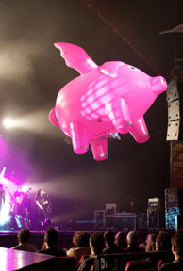
Live from New Zealand, The Pink Floyd Experience features a recreation of the music, staging and special effects used by Pink Floyd in what was to become the biggest-grossing tour in history. Awe-inspiring sets and visuals, lasers, stunning lighting, psychedelic projections and an extremely passionate 10-piece band combine for a full-scale, full-on Floydian Spectacular.
Two Brothers Roundhouse produced concert TBA
Saturday, August 24
Get the Led Out - The American Led Zeppelin
Friday, August 30, 8 p.m.
Tickets: $8, children 12 and under free
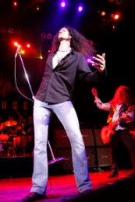
Get The Led Out recreates on stage the complete sound of Led Zeppelin’s recordings with the studio overdubs that Zeppelin themselves never performed live. Oh, and without the wigs. Dubbed “The American Led Zeppelin,” GTLO presents a two hour plus set that spans the mythic career of Britain’s legendary rock supergroup.
Two Brothers Roundhouse produced concert TBA
Saturday, September 21
Tickets to all RiverEdge Park Music Garden performances go on sale Monday, April 22 at 10 a.m. at riveredgeaurora.com. Tickets can also be purchased via phone by calling 630.896.6666, or in person at RiverEdge’s satellite box office, the Paramount Theatre, 23 E. Galena Boulevard in downtown Aurora, 10 a.m. to 6 p.m., or two hours prior to evening performances. Once open, RiverEdge will also operate a full-service box office on-site on concert and event days.
-more-

RiverEdge Music Garden Summer Schedule.4.15.13.pg 7 of 7
Two Brothers Roundhouse, the popular restaurant and brewpub located directly across the street from RiverEdge Park, is the official food vendor. Concessions at RiverEdge will offer a diversified menu along with a bar featuring Two Brothers’ craft beers, Anheuser-Bush products, wine, sodas, bottled water and more.
RiverEdge Music Garden is just the first phase of the City of Aurora’s larger, 30-acre RiverEdge Park redevelopment project, which is the centerpiece of a 10-year master plan for the city. When completed, the new regional festival park will feature wetland and urban wildlife areas, expanded public park space with direct access to the Fox River, a pedestrian bridge connecting both sides of the river, bike paths, fountains, a children’s playground and other public amenities. In keeping with its natural setting, RiverEdge Park will serve as a model of cutting edge and innovative sustainable environmental practices including products, programs and technology. For more information visit http://www.aurora-il.org/riveredge_park/index.php.

The RiverEdge Park project is being constructed by the City of Aurora through a combination of grants and donations from the State of Illinois Department of Commerce and Economic Opportunity (DCEO), the Fox Valley Park District, and the The Dunham Fund.

RiverEdge Music Garden is managed and programmed by the Aurora Civic Center Authority (ACCA), which also oversees operations for Aurora’s historic Paramount Theatre. ACCA has a proven track record of attracting audiences to downtown Aurora, with annual attendance at the Paramount Theatre having grown from 55,000 in 2010, to more than 200,000 for the current 2012-2013 season.
# # #

