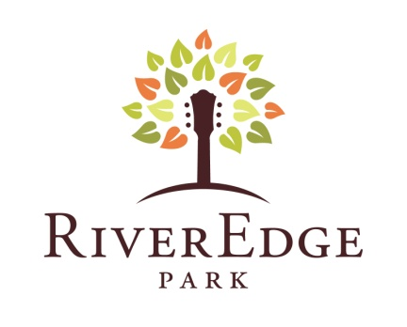
Press Release
Contact: Jay Kelly, L.C. Williams & Associates
jkelly@lcwa.com, 312.565.4623, 312.315.3935 (cell)
360 North Broadway St. Aurora, IL 60505
RiverEdgeAurora.com 630.896.6666
FOR IMMEDIATE RELEASE
AURORA’S NEW RIVEREDGE PARK MUSIC GARDEN ANNOUNCES GRAND OPENING PLANS, FIRST WAVE OF SUMMER CONCERT SCHEDULE
Sleek new outdoor concert venue on the banks of the Fox River, directly across from the Aurora Transportation Center, to attract thousands to downtown Aurora with top music acts, festival events and more; Grand opening is June 14 and 15 with Blues on the Fox festival; More major artists to be announced in coming weeks
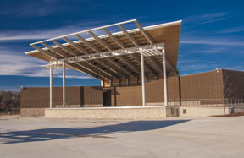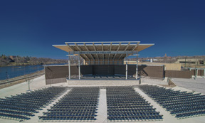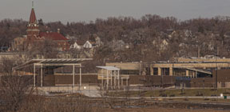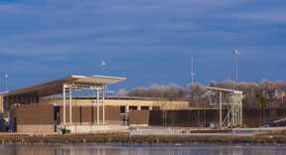
Go to http://paramountaurora.com/press-kits/ to download hi-res images of RiverEdge Music Garden.
AURORA, IL, April 15, 2013 – Chicago and Chicago’s western suburbs can add a beautiful, new outdoor concert venue to its short list of hot new summer destinations with the grand opening of the new RiverEdge Park Music Garden in downtown Aurora – Illinois’ second largest city – later this spring.
Inspired by outdoor entertainment facilities in Chicago’s Millennium Park and Northerly Island, and Milwaukee’s Summerfest, the new RiverEdge Music Garden is conveniently located at 360 North Broadway just steps from Aurora’s downtown business district, directly across from the Metra station, and on the eastern bank of the beautiful Fox River.
The new RiverEdge Music Garden, the first phase of Aurora’s impressive RiverEdge Park redevelopment project, will serve as an exciting, dynamic new entertainment destination for Chicago and its western suburbs. The new live outdoor entertainment venue is anchored by the contemporary John C. Dunham performance pavilion, which boasts state-of-the-art acoustics, flexible seating allowing for up to 2,500 seats in front of the stage, general admission for 6,000-8,000, plus a rooftop deck that hosts 300 VIPs – total capacity is approximately 8,500-10,500. Rooftop deck guests enjoy an amazing view of the stage, private restrooms, food and beverages along with a fantastic experience for their all-inclusive ticket price.
-more-

RiverEdge Music Garden Grand Opening.4.15.13.pg 2 of 3
According to Aurora Mayor Thomas Weisner, “The opening of RiverEdge Park’s Music Garden ushers in a new and exciting era of culture, music and celebration for Aurora that will be enjoyed by families across the entire Chicago region. This world-class facility is destined to become a source of community pride, and will serve as an economic catalyst for the future growth of downtown Aurora for years.”
Chicago-area media will be invited to an exclusive sneak-peek Press Preview on Thursday,
May 9 at Noon including a meet-and-greet with Aurora Mayor Weisner and RiverEdge Park architect David Steele, Muller & Muller Ltd. Architects of Chicago. From June 3-9, RiverEdge will hold its All Access Week events, which include the “Meet-N-Greet” public tours June 3-6; The Mayor’s “Front Row Preview Party” and Ribbon Cutting on June 7; and the Backstage Pass public tours and open house on June 8 and 9. More information on All Access Week to come.
RiverEdge will officially open on June 14 and 15 as the new site for Aurora’s popular 17th Annual Blues on the Fox festival sponsored by Rush-Copley Medical Center. The entire 2013 RiverEdge Season is sponsored by The Dunham Fund. RiverEdge Park will also host Aurora’s Downtown Alive! festival series, along with other festivals and an expanded and diverse line-up of concerts, family-friendly events and athletic competitions.
The initial schedule, with more major acts TBA in the coming weeks, is: Blues on the Fox, featuring Dr. John, JJ Grey & Mofro, The Stone Foxes, Tommy Castro and The Painkillers, Robert Randolph and The Family Band and a Blues Legend that cannot be announced until May 7. TBA (June 14 & 15); Amped Up Adventure Race (June 16); 97Nine and American English (June 28); Loretta Lynn and Randy Travis (June 29); Bruce in the USA and Fox Valley Orchestra with post-concert Fireworks (July 4); Color Vibe 5K Race (July 6); Trace Adkins, Aaron Lewis, Drake White and Blackberry Smoke (July 13); Sing-a-long-a Grease Movie in the Park (August 9); Sail Rock featuring Christopher Cross, Orleans, Gary Wright, Firefall, John Ford Coley, Robbie Dupree and Player (August 10); Peter Frampton’s Guitar Circus with Peter Frampton, Sonny Landreth and B.B. King (August 16); The Pink Floyd Experience (August 17); and Get the Led Out - The American Led Zeppelin (August 30).
“As you can see, there’s something for every live music fan throughout Chicagoland and we are not done programming yet. In fact, we have a more major concert announcements coming within the next few weeks,” said Tim Rater, President and CEO of the Aurora Civic Center Authority (ACCA). “Our goal is to offer a strong combination of national headliners, local performing arts productions, and stage a wide variety of exciting special events all aimed at boosting Aurora’s profile as a growing and vibrant destination for live entertainment.”
Two Brothers Roundhouse, the popular restaurant and brewpub located directly across the street from RiverEdge Park is the official food vendor. In addition, Two Brothers will host three outdoor concerts at RiverEdge on July 20, August 24 and September 21. Concessions at RiverEdge will offer a diversified menu along with a bar featuring Two Brothers’ craft beers, Anheuser-Bush products, wine, sodas, bottled water and more.
-more-

RiverEdge Music Garden Grand Opening.4.15.13.pg 3 of 3
The RiverEdge website, RiverEdgeAurora.com, launches today, April 15 at 10 a.m. Tickets to country music superstars Loretta Lynn and Randy Travis go on sale Saturday, April 20 at 10 a.m. Tickets to all performances go on sale Monday, April 22 at 10 a.m. Tickets can also be purchased via phone by calling 630.896.6666, or in person at RiverEdge’s satellite box office, the Paramount Theatre, 23 E. Galena Boulevard in downtown Aurora. Once open, RiverEdge will also operate a full-service box office on-site on concert and event days.
RiverEdge is just the first phase of the City of Aurora’s larger, 30-acre RiverEdge Park redevelopment project, which is the centerpiece of a 10-year master plan for the city. When completed, the new regional festival park will feature wetland and urban wildlife areas, expanded public park space with direct access to the Fox River, a pedestrian bridge connecting both sides of the river, bike paths, fountains, a children’s playground and other public amenities. In keeping with its natural setting, RiverEdge Park will serve as a model of cutting edge and innovative sustainable environmental practices including products, programs and technology. For more information about the long-term RiverEdge Park plans, visit
http://www.aurora-il.org/riveredge_park/index.php

The RiverEdge Park design team was led by Christopher Burke Engineering Ltd. (Project Manager and Engineering) and included Muller & Muller Ltd. (Architects), Wills, Burke, Kelsey Ltd. (Wetland Design), Schuler Shook (Theater and Lighting Design), and Talaske Sound Thinking (Sound Engineering).

The RiverEdge Park project was constructed by the City of Aurora through a combination of grants and donations from the State of Illinois Department of Commerce and Economic Opportunity (DCEO), the Fox Valley Park District, and The Dunham Fund.

The construction of RiverEdge Park Music Garden was overseen by the Construction Management team of R.C. Wegman Construction Company and Wills, Burke, Kelsey Ltd. which created over 300 construction jobs with over 58% of the work going to local contractors, nearly 10% going to minority owned businesses and 5.5% going to women owned businesses.

RiverEdge Park is being managed and programmed by the Aurora Civic Center Authority (ACCA), which also oversees operations for Aurora’s historic (1,888 seat) Paramount Theatre and the (216 seat) Copley Theatre. ACCA has a proven track record of attracting audiences to downtown Aurora, with annual attendance at the Paramount Theatre having grown from 55,000 in 2010, to more than 200,000 in both the 2011-12 and current 2012-2013 seasons.

# # #

